**Title: The Mat of the Middle East: A Persian Rug, a Hebrew Scroll**

**A Satirical Look at the Israel-Iran Disagreement and its Global Ripple Effects**

**Author: Ojonupayi Rita**

**Table of Contents**

1. Chapter One: The Camel Has Two Humps
2. Chapter Two: When Cousins Quarrel
3. Chapter Three: War Flirting and Proxy Marriages (Now with Wi-Fi)
4. Chapter Four: The Cost of Unrest — And the Price Tag of Progress
5. Chapter Five: The Neighbours’ Nightmare (Now in 4K Resolution)
6. Chapter Six: Of Carpets, Scrolls, and Silicon Chips
7. Chapter Seven: The Moral of the Mat
8. Data Dashboard Summary (2025 Metrics)
9. About the Author

**Chapter One: The Camel Has Two Humps** Long before oil flowed like honey and missiles flew like mosquitoes, Iran and Israel were distant cousins in the family of ancient civilizations. One made carpets and poetry; the other made scrolls and prophets. Both had prophets, actually and pride thicker than a block of feta.

Israel, reborn in 1948, came out swinging surrounded by enemies and armed with dreams as sharp as a rabbi’s tongue. Iran, meanwhile, enjoyed tea with the Shah until 1979, when Ayatollahs entered like unexpected dinner guests who won’t leave and frown at your Netflix choices.

Back then, Israel and Iran weren’t enemies — they actually exchanged hugs, trade, and intelligence secrets. But then, like two guests fighting over who controls the TV remote, religion, ideology, and politics rewrote the script.

**Chapter Two: When Cousins Quarrel** Iran said, “Death to Zionism!” Israel replied, “We prefer not dying, thank you.”

It was the start of a long-distance cold war. No direct bullets — just a million cyber hacks, shadow games, assassinations under moonlight, and mutual chest-beating at UN conferences.

Iran backed Hezbollah and Hamas like a stubborn aunty who insists on funding her nephew’s bad habits. Israel, armed to the teeth and backed by Uncle Sam, developed tech that could track a sneeze in Syria.

Nuclear programs? Oh yes. Iran said its uranium was “for peace.” The world rolled its eyes so hard, satellites blinked. Israel, a master of ambiguity, neither confirmed nor denied its nuclear might like a rabbi who smiles but doesn’t answer.

**Chapter Three: War Flirting and Proxy Marriages (Now with Wi-Fi)** Direct war never quite erupted — not for lack of trying. Instead, both nations mastered the art of war flirting: surgical airstrikes in Syria, mysterious explosions in Iranian labs, cyber sabotage with poetic names like *Stuxnet*, and cryptic tweets that made oil prices jitter like a belly dancer in Baghdad.

But the war was no longer just boots and bombs. It was USB drives and backdoors.

Israel became the Silicon Valley of warfare its Iron Dome intercepted missiles like an overprotective mother swatting flies from her child. Iran built drones the size of lawn chairs and taught them to fly over Saudi oil fields with the grace of a drunk pigeon.

Economically, the sanctions turned Iran’s economy into a bicycle with square wheels. Inflation soared, while Israel’s economy, although robust, braced for every escalation like a soldier with insomnia.

Socially, Iranians protested in poetry, Israelis grumbled through comedy clubs. War fatigue wasn’t just in the air it was marinated in every falafel.

**Chapter Four The Cost of Unrest the Price Tag of Progress**

Iran youth unemployment ballooned while thousands of brilliant minds coded their way to Canada. Tech industries withered under embargoes. A nuclear physicist could split atoms but couldn’t order a MacBook.

Israel, Defense tech thrived. The phrase “Startup Nation” became “Surveillance Nation.” - The tourism sector limped like a wounded camel.

Both countries excelled in tech-for-war AI targeting systems. - Smart borders. Satellites that could count goats in Yemen.

The nuclear standoff? Iran enriched uranium like it was brewing espresso. Israel stayed silent, but submarines patrolled like sharks in the Red Sea.

**Chapter Five: The Neighbours’ Nightmare (Now in 4K Resolution)** The Gulf countries watched like cautious neighbors. Saudi Arabia, UAE, Bahrain — all installed anti-missile systems and cyber shields.

Technology’s Ripple Effects: - Oil markets responded faster to Tel Aviv tweets than to OPEC meetings. - Gulf stock exchanges sneezed every time a scientist disappeared in Iran. - Surveillance systems boomed — drones, CCTV, biometric tracking.

Globally: - Refugees increased. - Arms deals soared. - Diplomats aged prematurely.

**Chapter Six: Of Carpets, Scrolls, and Silicon Chips** Peace is possible not in bombs or barked threats, but in: - Digital diplomacy. - Joint tech hubs. - Cultural trade-offs.

If peace breaks out the Gulf becomes a tech and tourism paradise. - Israel focuses on curing cancer. - Iran revives Persian wisdom.

**Chapter Seven: The Moral of the Mat** Like a Persian rug and a Hebrew scroll, Iran and Israel are intricate, historic, and misread by outsiders. War may burn pages, but peace can write new ones. Even rivals need sleep no one wants to nap on a nuclear crater.

**Data Dashboard Summary (2025 Metrics)**

| Metric | Value |
| --- | --- |
| Oil Volatility (OVX) | 71.6 |
| Nuclear Risk Index | 4 (Scale 0–10) |
| Israel Tech Export | 20% of GDP |
| Iran Inflation | ~40% |

Visuals: - [Pie Chart – Relative Metrics](http://2025_pie_chart.png) - [Bar Chart – Absolute Metrics](http://2025_bar_chart.png)

Here are separate visuals:

1. **Pie Chart – Relative Distribution of 2025 Metrics**
2. **Clustered Bar Chart – Absolute Values of Key Indicator**

Here are your two separate visuals:

1. **Pie Chart – Relative Distribution of 2025 Metrics**
2. **Clustered Bar Chart – Absolute Values of Key Indicator**

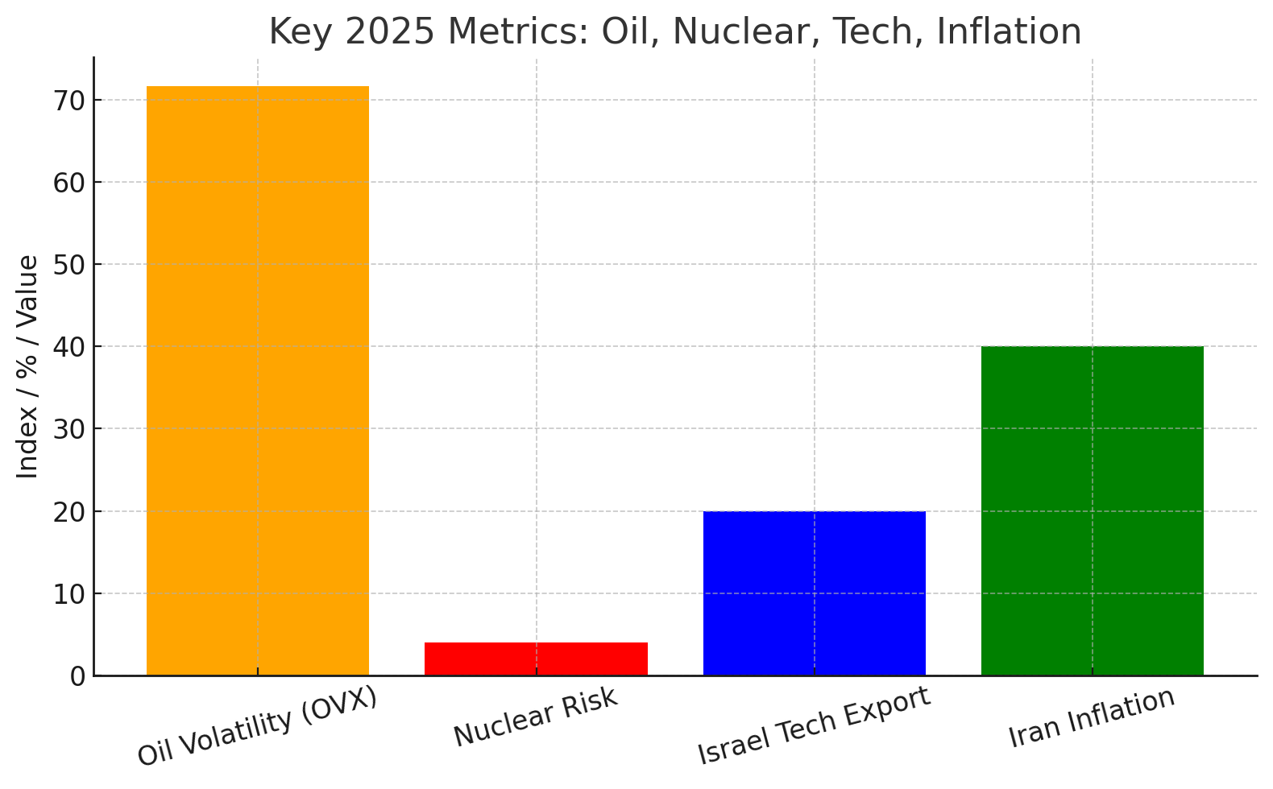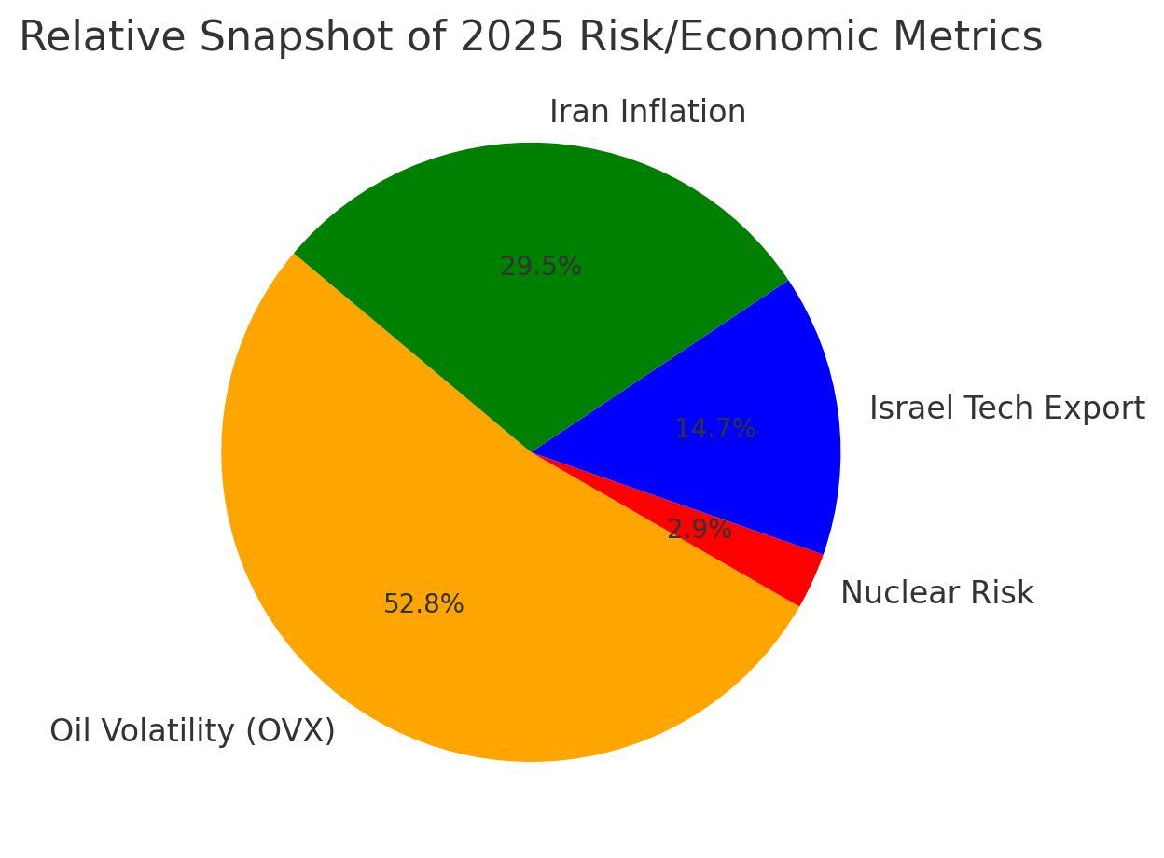



**About the Author**

Ojonupayi Rita is a Nigerian writer and data analyst passionate about blending satire, global politics and storytelling. When she’s not decoding conflict dynamics or designing dashboards, she explores ways literature can make complex world issues digestible, humorous and human.